# Introduction

## Company Profile

The company was set up as a manufacturer of interactive platforms and tools. The focus of our business is mainly on the user interface design and functionality of the product. Our products’ design specifications follow the trend adopted by the best field experts in software engineering as well as complying with the current industry standard.

Our team consist of highly trained and qualified engineers that constantly review and invent new methods to design higher quality product such as exquisite user interfaces and instructive functions.

## Vision

* To be the leading and cutting edge manufacturer of interactive platforms, designing innovative features and user friendly device.
* To understand and deliver products that consumers are most sort after.
* To create a better everyday life for everyone.
* To provide a world of solutions for the ever growing needs of the many.

# Roles and Responsibilities

## Organizational Structure

In order for any organization to fully operate at its fullest potential and capabilities, roles and responsibilities of each personnel in the company has to be established. Figure 1 below shows the organizational structure of the company.

The project manager carries the responsibility of ensuring that the group members work in concordance and harmony. Having to oversee that all the members of the company comply with the company’s policies and procedure is also part of the project manger’s responsibility.

As the roles mentioned down in the figure, each of them gets more into specialised operation whereby the products are being designed, tested, and strategize into the market. In order to ensure that a product is being delivered on schedule, communications between each team members is essential. This is done by having weekly meeting to review the progress of the production in each team and also consistently reviewing the deliverables and eventually every crucial milestone.

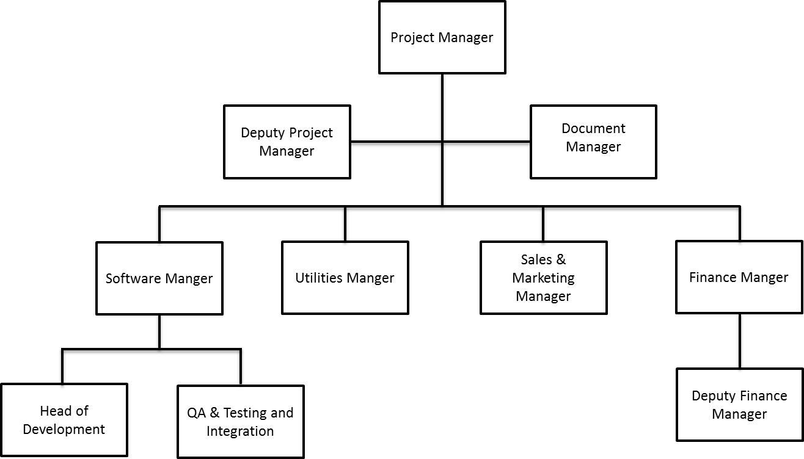

Figure 1 Organizational structure of the company

## Project Manager

### Role Description

### Risk Management

### Quality Assurance Metrics

## Deputy Project Manger

### Role Description

### Risk Management

### Quality Assurance Metrics

## Document Manger

### Role Description

### Risk Management

### Quality Assurance Metrics

## Software Manger

### Role Description

### Risk Management

### Quality Assurance Metrics

## Head of Development

### Role Description

### Risk Management

### Quality Assurance Metrics

## Testing and Integration Manager

### Role Description

The roles and responsibilities of a Testing and Integration Manager is to ensure that procedures that involved with testing and integration of the project is being managed at the highest quality possible. He or she needs to have a comprehensive view of the testing and integration phase so as to competently perform his or her responsibility.

The main responsibility of the testing and integration manager is to formulate a set of testing strategies whereby the team members have to follow closely. Guiding the team members on how to write a proper and relevant test is also a part of the testing and integration manager’s responsibility. The manager also has to come up with a general set of tests which are expected to pass when integrating the individual components together. The testing and integration plan is represented in a form of a Kanban Board using JIRA to show the progress of each task. The team members have access to the Kanban board and they are to update their progress on certain tasks regularly. Additional information such as defects or bugs has to be recorded on the Kanban board as well. With the Kanban board, the testing and integration manager can track the progress of the project and report to the software manager as following.

The key responsibilities of the testing and integration manager include:

* Manage the procedures that involve testing.
* Manage the procedures that involve integration of multiple modules.
* Formulate a set of testing strategies whereby the team members have to follow closely.
* Guide the team members on the how to write a test.
* Ensure that the test of each individual component is practical, relevant and consistent.
* Formulate a general set of tests which are expected to pass when integrating the individual components together.

Assign various tasks to team members according to the Kanban board.

* Ensure that the team members update their progress including problems or bugs onto the Kanban board weekly.
* Report the progress to the software manager.

### Risk Management

|  |  |
| --- | --- |
| **Risk** | **Solution** |
| Development department unable to meet the deadline. | Allocate more time or reschedule testing and integration phase so as to accommodate for the delay. |
| Individual task during testing or integration phase overdue. | Record the problems on the Kanban board and allocate more time or more manpower for that particular task. |
| Error encountered where integrating multiple modules, but could not find a solution to that problem. | Consult the Software department to rectify the problem. |
| Member of the team decided to leave the company. | Allocate time for training a new member. Reshuffle the workload among the remaining team members. |

Any rescheduling has to be discussed with the software manager and as well as the testing and integration team members. The project manager has to be notified if such cases happened.

### QA Metrics

|  |  |
| --- | --- |
| **Metric** | **How measured** |
| Integration phase on schedule. | Review the test written for individual component regularly to ensure that individual components are working perfectly. Monitor the integration phase closely. |
| Testing phase on schedule. | Ensure that the integration phase is operating smoothly. Monitor the testing phase closely. |
| Total tests conducted. | Refer to Kanban board. |
| Errors and bugs fixed promptly. | Refer to Kanban board. |

## Utilities Manager

### Role Description

### Risk Management

### Quality Assurance Metrics

## Sales & Marketing Manager

### Role Description

### Risk Management

### Quality Assurance Metrics

## Finance Manager

### Role Description

### Risk Management

### Quality Assurance Metrics

## Deputy Finance Manger

### Role Description

### Risk Management

### Quality Assurance Metrics